[How to make obstacle avoiding robot using Arduino & Ultrasonic sensor ?](http://mechstuff.com/how-to-make-obstacle-avoiding-robot-using-arduino-ultrasonic-sensor/)

### Requirements :-

1. Chassis OR any toy car.
2. Arduino UNO/Mega.
3. Ultrasonic sensor HC SR-04.
4. 2 DC motors.
5. 9V/12V 1A battery.
6. Motor driver module L298.
7. Jumpers.
8. Single stranded wires.

### Procedure :-

So yes, I’m going to divide the whole making into 4 parts –

Connections of Ultrasonic sensor    **→**    Connections of L298N    **→**Code    **→**Testing

If you haven’t used or experimented before with the ultrasonic sensor, I would suggest you to get familiar with it first ! I have a detail tutorial on ultrasonic sensor HC SR-04 which will guide you throughout !

Connections :-

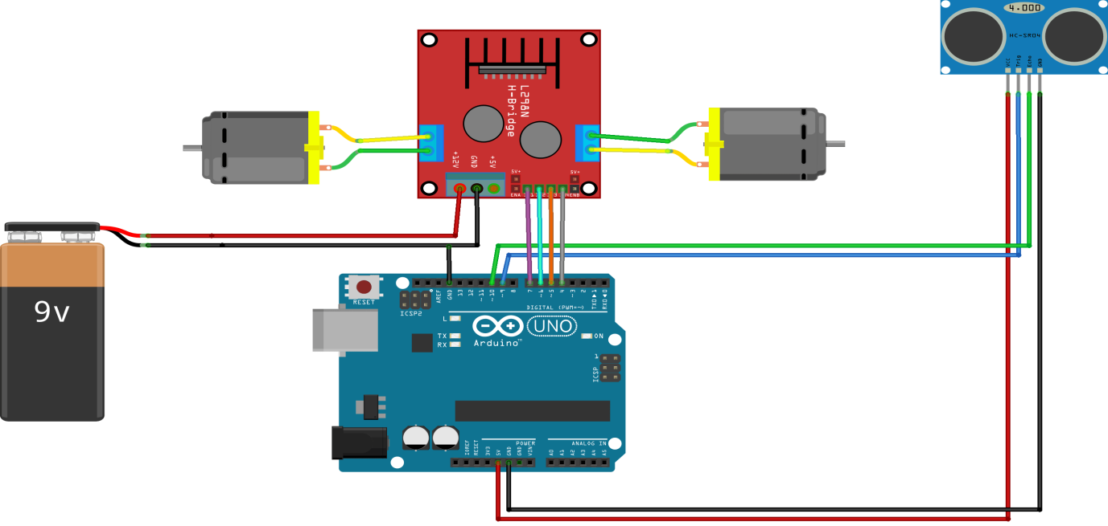

#### Connections of Ultrasonic sensor –

1. VCC – VCC terminal of Arduino.
2. GND – GND terminal of Arduino.
3. Trigpin – digital pin 9 on Arduino.
4. Echo pin – digital pin 10 on Arduino.

#### Connections of L298N –

1. +12V – Positive terminal of the battery.
2. GND – a)GND of Arduino   b)Negative terminal of battery.
3. Input terminal 1 – Pin 4
4. Input terminal 2 – Pin 5
5. Input terminal 3 – Pin 6
6. Input terminal 4 – Pin 7
7. Output terminal 1 – Positive of first motor.
8. Output terminal 2 – Negative of first motor.
9. Output terminal 3 – Positive of second motor.
10. Output terminal 4 – Negative of second motor.

### Coding :-

int trigPin = 9;

int echoPin = 10;

int revright = 4; //REVerse motion of Right motor

int fwdleft = 7;

int revleft= 6;

int fwdright= 5; //ForWarD motion of Right motor

int c = 0;

void setup() {

//Serial.begin(9600);

pinMode(5, OUTPUT);

pinMode(6, OUTPUT);

pinMode(4, OUTPUT);

pinMode(7, OUTPUT);

pinMode(trigPin, OUTPUT);

pinMode(echoPin, INPUT);

// put your setup code here, to run once:

}

void loop() {

long duration, distance;

digitalWrite(trigPin,HIGH);

delayMicroseconds(1000);

digitalWrite(trigPin, LOW);

duration=pulseIn(echoPin, HIGH);

distance =(duration/2)/29.1;

//Serial.print(distance);

//Serial.println("CM");

delay(10);

if((distance>20))

{

digitalWrite(5,HIGH); // If you dont get proper movements of your robot,

digitalWrite(4,LOW); // then alter the pin numbers

digitalWrite(6,LOW); //

digitalWrite(7,HIGH); //

}

else if(distance<20)

{

digitalWrite(5,HIGH);

digitalWrite(4,LOW);

digitalWrite(6,HIGH); //HIGH

digitalWrite(7,LOW);

}

}

### Testing :-

If the distance detected by the ultrasonic sensor is less than 25cm, then the bot will take a turn else, it will keep moving straight ! Simple… right ?